📊 GBPUSD (H1) — Decision
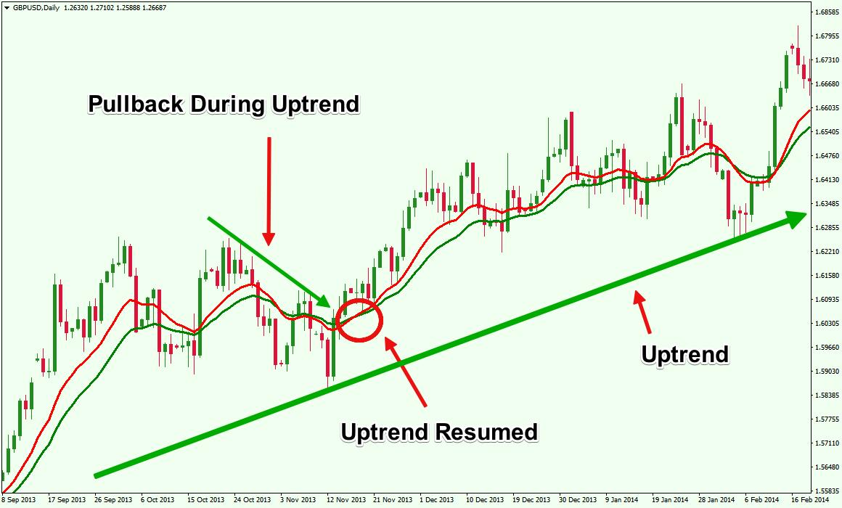
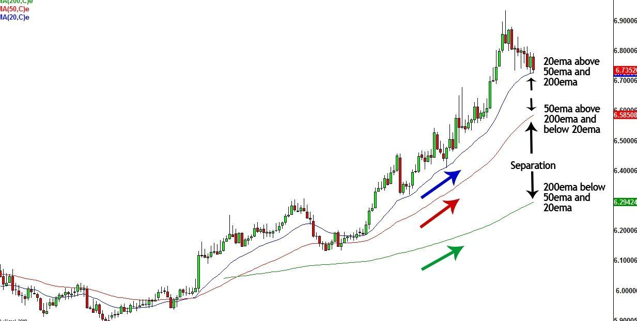
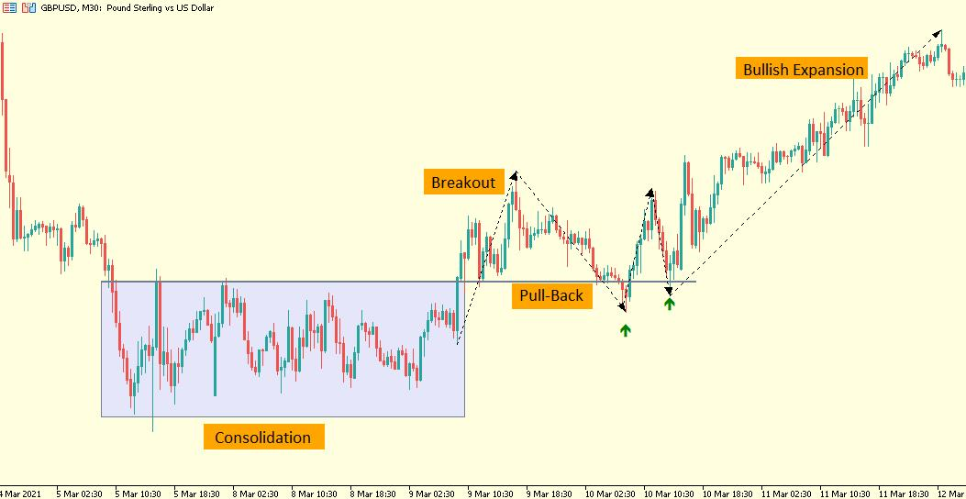
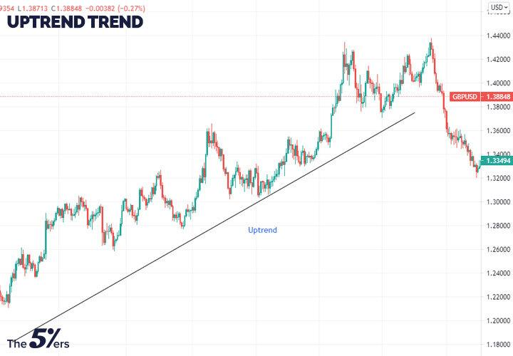
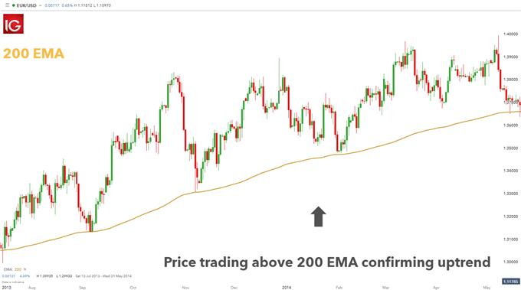
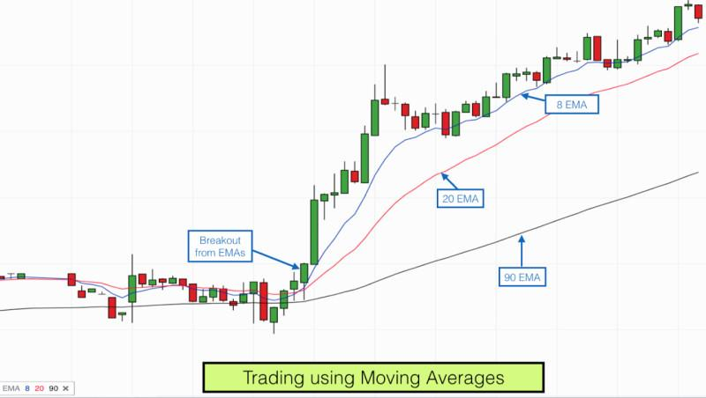
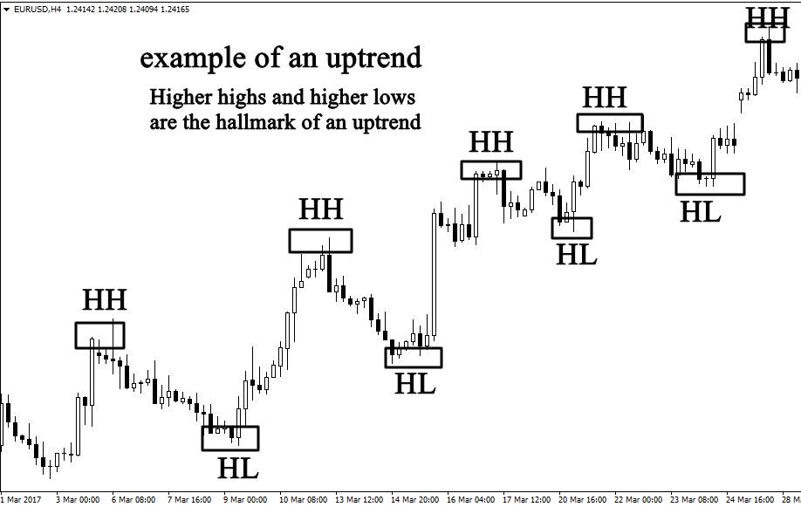

🔍 What I’m Seeing
- Clear trend shift to bullish
- EMA 50 (red) has crossed above EMA 200 (blue) ✅
- Price made a strong upward move
- Now we see a pullback / correction
👉 This is a BUY market with retracement

⚠️ Current Situation
Right now:
- Price is pulling back from highs
- Not strongly bearish, just cooling down
👉 This is where many traders make a mistake and sell too early

🎯 Smart Trade Plan

🟢 BUY Setup (Best Option)
Wait for:
- Price to respect EMA 50
- A strong bullish candle (rejection from pullback)
👉 Then BUY

🔴 SELL Setup (Only if this happens)
Sell ONLY if:
- Price breaks below EMA 200
- Trend structure flips (lower lows form)
👉 Not happening yet

❌ Avoid
- Selling during a pullback
- Entering without confirmation

🧠 EA Perspective
Your EA should:
- Focus on BUY trades
- Use pullback + confirmation logic

🔥 Final Answer
👉 Direction: BUY
👉 Action: WAIT for confirmation (pullback bounce)

If you want next:
I can now upgrade your EA with:
- ✅ Pullback entry logic
- ✅ Stop Loss / Take Profit (ATR-based)
- ✅ Trade limiter (no overtrading)
Just say: “final optimize EA” 🚀

